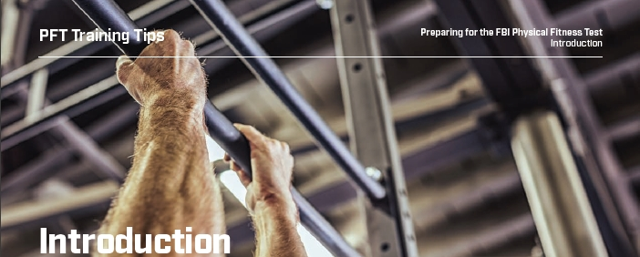

**Taking the First Step:**

When applying for a Special Agent position at the Federal Bureau of Investigation (FBI), one of the most daunting challenges for some applicants is the FBI’s Physical Fitness Test (PFT). However, rest assured — with the proper training, you can and will pass the PFT with flying colors!

To assist you on your journey, we have developed this training guide to help you build skills and strengthen the muscle groups essential to passing the four mandatory sections of the PFT — sit-ups, the 300-meter sprint, push-ups and the 1.5-mile run. We’ve also included training tips for a fifth event, pullups, required only for candidates in the Tactical Recruitment Program (TRP).

This guide provides detailed instruction, drills and photos depicting the proper form and technique to build strength and capacity.

You may apply without a passing score on the self-PFT — for now. But keep up your training, because if you’re accepted, you will need to pass the PFT soon!

An FBI Special Agent career is the opportunity of a lifetime and we’re looking for applicants from a wide range of educational and career backgrounds. Come join the more than 37,000 men and women who have answered the call to serve their country, protect their communities and uphold the Constitution. Good luck!



**Objective:** Provide an overview of Core Stabilization Training (CST) techniques designed to enhance abdominal and trunk muscular endurance while, at the same time, better match trunk muscle function and neuromuscular control. Empirical research suggests there is no detrimental impact on performance of sit-ups when traditional training is replaced with Core Stabilization Training.

**Core Stabilization Training Skill Builder:**

Drill No. 1: Prone Plank or Bridge:

**Instructions:** You will begin by lying on the floor or mat in a prone position, with feet placed approximately at hip-width and arms placed at shoulder-width, with elbows under the shoulders. You will dorsiflex the ankles (draw toes toward your nose) to help distribute the workload more evenly as you straighten knees, tighten gluteal muscles and “brace” or stiffen abdominal muscles to form a “plank” or bridge. The key element is to maintain neutral spinal alignment while holding this hover position on the forearms and toes.

**Training Prescription:** Start with three to four sets of 10 to 15 seconds each, with equal amounts of rest between sets.

|  |  |
| --- | --- |
| **Regressions** | **Progressions** |
| Elevate the arms using a chair, bo01x, desk, etc. | Slide elbows forward of the shoulder. |
| Rest on knees rather than toes. | Plantar-flex or point the toes. |
| Straight-arm planks. | Press up to straight arms; elbow or shoulder taps; knee-to-elbow. |

****Drill No. 2: Side Plank or Bridge:

**Instructions:** You will begin by lying on the floor or mat on your side, with feet stacked together and the elbow of the bottom arm placed directly under the shoulder. Then elevate the hips off the floor using the outside of the bottom foot and forearm. The key element is to maintain neutral spinal alignment while holding this hover position on the forearms and toes.

**Training Prescription:** Similarly, start with three to four sets of 10 to 15 seconds each, with equal amounts of rest between sets.

|  |  |
| --- | --- |
| **Regressions** | **Progressions** |
| Start with knees bent, resting on the outside of the bottom knee and lower leg. | Slowly raise and lower the hips from the ground repeatedly. |
| Scissor the legs, bringing the top leg forward and resting on both feet. | Slowly rotate and reach the top arm under the support arm and return. |
| Straighten the bottom support arm and/or use the top arm to assist with support. | Slowly swing the top leg forward and back, maintaining alignment. |

Drill No. 3 : Bird Dog (Quadruped Alternating Arm-Leg Raises):

**Instructions:** Start in a quadruped position with knees directly below hips and hands directly under shoulders. Then slowly raise one arm forward with thumb up, while simultaneously extending the opposite leg to the rear. The key element is to maintain neutral spinal alignment while the extremities are moving in space with reduced points of contact with the ground — like a table missing two of its legs.

**Training Prescription:** Start with three sets of five to 10 repetitions on both sides with controlled and deliberate movement speeds and a pause at the top position.

|  |  |
| --- | --- |
| **Regressions** | **Progressions** |
| Elevate one arm while both legs remain still. | Extend the pause at the top position. |
| Elevate one leg while both arms remain still. | Add an elbow-to-opposite-knee touch near the waist prior to the arm/leg raise. |

Drill No. 4: Hip Lift (Supine Plank or Shoulder Bridge):

**Instructions:** Start on your back with knees bent at approximately a 90-degree angle and arms on the floor at approximately a 45-degree angle at the shoulder. Brace abdominals while driving heels into the floor, raising hips off the floor until hips are fully extended. The key is to align the shoulders, hips and knees at the top of the movement and hold this position.

**Training Prescription:** Start with three to four sets of 10 to 15 seconds each, with even amounts of rest between sets.

|  |  |
| --- | --- |
| **Regressions** | **Progressions** |
| Elevate the head and shoulders on a bench or chair. | Extend the pause at the top position. |
| Elevate the hips and slowly lower back down. | Raise the hips and hold with a single leg. |
|  | Add a single-leg march or “windshield wiper” movement. |



**Objective:** Provide an overview of the movement training techniques that will enhance the development of high velocity running skills. This training incorporates basic motor skills and drills to condition the tendons, ligaments, muscles and fascia.

**Sprinting Skill Builder:**

**Warmup:** Utilizing a 10-yard distance, perform a dynamic warmup emphasizing the running muscles. Start with dynamic stretching while walking along the 10-yard distance, progressing to more dynamic movement drills such as lateral shuffles, carioca and tall-fall-run.

**Drills to Solidify Good Running Mechanics:** Running fast requires optimal form to maximize performance and minimize injury. The following drills will focus on developing the proper hip drive and arm action necessary to run fast.

**Hopping Drill:** Hopping is a basic, minimal impact, plyometric exercise. Fast, repeated, multidirectional hops will foster lower-body joint integrity, enhance ankle stability and strengthen tendons. Hops are necessary for sedentary, older individuals to perform. Research shows tendons and ligaments degrade over time and ultimately become more susceptible to injury if one hasn’t been training explosively on a regular basis. Hops have been shown to warm up the central nervous system (CNS) and prepare the body for explosive training.

**Start Drill:** Valuable time is lost with a poor start. A few seconds difference can equal a multiple percentile ranking increase (or decrease) on the 300-meter sprint event. The start should emphasize optimal positioning to efficiently impart force into the ground. This means the arms should be ready to violently punch forward and rip backwards to maximize upper body involvement. The body should be low to the ground with a slight forward lean in order to maximize force into the ground (with feet staggered, squat down with a forward weight shift, knees forward of the toes). The first several steps should be short and choppy in order to maximize steps into the ground for acceleration before gradually progressing to your normal stride length.

**Strength/Endurance Drill:** Running fast requires a great deal of strength. Endurance is also required because one must be able to sustain maximal force for an extended period. These drills will develop the strength and endurance specific to the 300-meter sprint.

Drill No. 1: Hip Drive:

**Instructions:** Lean against a wall by flexing the ankle joint and not the hip/back. There should be a straight line from ankle to head. Raise the right knee as high as you can while maintaining this straight line. The right foot should be dorsiflexed. Use the cue, “Knee up, toes up.” Drive the right leg down into the ground and raise the left leg (knee up, toes up). The heels should never hit the ground during this drill. You are driving the ball of the foot into the ground. If a wall isn’t nearby, find a partner; you will lean forward while your partner places his/her hands on your shoulders to prevent you from falling.

**Advanced Tweak:** Incorporate the arm drive drill with the hip drive drill. Your partner will place his/her hands on your shoulders. This will allow you to practice good arm mechanics with the hip drive drill.

Drill No. 2: Arm Drive:

**Instructions:** You will stand and bend your elbows to a 90-degree angle. Then you will swing the arms forward and backward by initiating the movement from the shoulders and not the elbows. Remember to “drive from the shoulders.” You can also think: “Thumb in the eye and pick your pocket.” This cue emphasizes the great arm movement that should be involved with running the 300-meter event. This drill should be performed slowly in order to learn the correct upper-body movement pattern.



Drill No. 3: Seated Arm Drive:

Instructions: The upper-body arm mechanics are the same as above except that you are seated. You will violently drive your arms forward and backward. When done with the proper amount of force and, if the arm drive is initiated from the shoulder, you will be bouncing up and down on the floor. The arms should be moving as fast as possible back and forth.

Drill No. 4: 1, 2, 3 Ankle Hops:

**Instructions:** You will stand on a solid surface such as the track, gym floor or pavement. This hop is performed by jumping and plantar flexing the ankles, then driving the balls of the feet into the ground. Repeat for three consecutive, stationary hops. Focus on slapping the ball of the foot against the ground and quickly pulling the toes toward the shin. With each hop, focus on building force and jumping higher.

Remember that “the floor is hot” and you need to minimize ground contact time. Your knees shouldn’t bend as in performing a squat and your heels shouldn’t contact the ground.

Drill No. 5: Line Ankle Hops (Forward):

**Instructions:** Find a line on the ground over which to hop. Toes should be behind the line and feet should be shoulder-width apart. On the “go” command, you will hop back and forth (only clearing the toes over the line) for the specified period, as quickly as possible. Again, remember that “the floor is hot” and you need to minimize contact time with the ground.

 Drill No. 6: Line Ankle Hops (Lateral):

**Instructions:** This is the same as Drill No. 5, except you straddle the line with one foot next to the line. The feet should be paral­lel to the line and shoulder-width apart. On the “go” command, you will quickly hop back and forth, bringing the foot down on the other side of the line. There is a tendency to bring the feet together during this drill; keep your feet shoulder-width apart throughout the duration of the drill.

Drill No. 7: 15-Meter Start Drill:

**Instructions:** Set up on a starting line. The proper start position should be emphasized (staggered stance with the dominant leg forward, squat position with a forward lean onto the toes, lead leg shin forward of toes, opposite arm forward of lead leg). On the “go” command, you will drive off both feet and quickly drive the backward arm forward. You will be taking many quick, short steps to accelerate. Gradually the stride should lengthen as maximal speed is achieved.

Your normal stride length should not be a heel strike. If you are unable to stop striking the heel, the distance should be shortened to a length that reinforces driving off the balls of the feet. You should be placing the foot down at or behind the hip, instead of reaching the foot out in front of you. Recall the hip drive drill and perform more reps of this drill.

Drill No. 8: Wide-out Drop Squat:

**Instructions:** You will start with a narrow stance. Initiate the squat by first hinging at the hip and then dropping into the squat (back and shin angle should be similar). Drive the feet into the ground and return to a standing position with feet close together. These reps are performed in a quick piston-like manner.

Drill No. 9: Leg Crank:

**Instructions:** You will perform 10 squats, 10 forward lunges, five split squats and five opposite-leg split squats in a fast, controlled manner. Squats should be performed with the feet wider than shoulder-width apart. The movement is initiated by a hip hinge. At the bottom, the back and shin angle should be similar. In the forward lunge, the back should remain upright (back should look the same as when standing) in the bottom position of the lunge. You should strive for lunging to a depth in which the trailing knee is hovering just above the ground. For the split squat, you will take a shoulder-width stance and stagger the feet by several inches front to back. You will lower into the squat by hip-hinging and then return to the start position. The heel of the trailing foot should rise off the ground.

**300-Meter Skill Builder Workout:**

Perform a dynamic warmup.

**Drill No. 1: Hip Drive:**

»» After taking time to practice.

»» Five sets of three reps at maximal speed.

**Drill No. 2: Arm Drive:**

»» Take two minutes to practice the drill.

**Drill No. 3: Seated Arm Drive:**

»» Three sets of 10-second rounds.

»» Rest for 30 seconds.

»» Three sets of 10-second rounds.

**Drill No. 4: 1, 2, 3 Ankle Hops:**

»» Take two minutes to practice the drill.

**Drill No. 5: Line Ankle Hops (Forward):**

»» Three sets of 10 seconds (with 10 seconds of rest between sets).

**Drill No. 6: Line Ankle Hops (Lateral):**

»» Three sets of 10 seconds (with 10 seconds of rest between sets).

**Drill No. 7: 15-Meter Start Drill:**

»» 10 reps (the walk back to the starting line is the rest period).

**Drill No. 8: Wide-out Drop Squat:**

»» Three sets of 10 reps (with 30 seconds of rest between sets).

**Drill No. 9: Leg Crank:**

»» One set (no rest period).

*Note: The above 300-Meter Skill Builder Workout should be modified based on your ability. If you are not able to perform the specified sets or reps, more time may be needed between drills.*

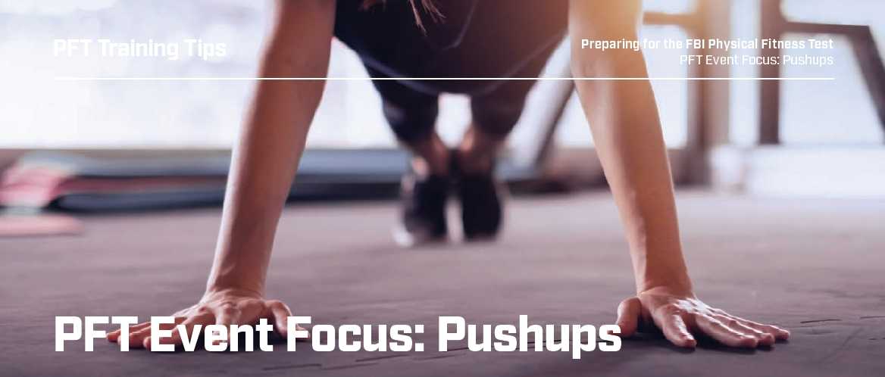

**Objective:** Provide an overview of the movement training techniques that will enhance the development of proper protocol push ups. Provide a training prescription that will aid in increasing upper body strength.

**Push Up Skill Builder:**

**Movement Preparation:** The following movement preparation (Drills 1 – 5) should be performed for at least two to four weeks prior to starting a push up training schedule. The purpose of these exercises is to condition the primary, stabilizing and neutralizing muscles to support a stringent push up regimen while minimizing the potential of an injury.

Drill No. 1: Core Stabilization:

**Instructions:** Assume a prone plank position on the floor. Feet should be approximately 3 inches apart, elbows directly below the shoulders with forearms on the floor and the back in a straight line from ankle to ear. Begin by bracing (tightening) the core muscles, alternately raising and holding one leg or arm, or both opposing leg and arm, while maintaining a flat back (minimize trunk rotation).



**Training Prescription:** Raise one leg, hold for 10 to 15 seconds. Progress to raising one arm, hold for 10 to 15 seconds. Complete by raising opposite arm and leg, hold for 10 to 15 seconds. Repeat the same pattern for the opposite side. Do three to five sets. The key is to maintain a flat back and to not allow the body to overcompensate (rotate or shift).



Drill No. 2: Scapula Development:

**Instructions:** Assume a front-leaning-rest position on the floor, feet no more than 3 inches apart, arms straight with hands on the floor outside of the chest and back straight. Maintain this front-leaning-rest position throughout the exercise. Pull the shoulder blades together while projecting the chest downward, followed by lifting the chest upward and rolling the shoulder blades apart.

**Training Prescription:** Perform 10 to 12 slow and controlled repetitions. Rest and then repeat one more set.

Drill No. 3: Anterior Deltoid Development:

**Instructions:** In a standing position, hold a weight plate (or dumbbell) at thigh level. With straight arms, brace your core (abdominal and back muscles) and raise the weight plate from thigh level to eye level; return to the thigh.

**Training Prescription:** Perform this movement pattern using a 10- to 15-lb. weight for eight to 10 controlled repetitions. Repeat one more set. The key is to maintain stability of the core and back muscles. Reduce the weight if the core and back muscles become unstable (shifting in the body).

Drill No. 4: Tricep Development:

**Instructions:** Assume a supine position on the floor or bench. Holding dumbbells in both hands, elevate and maintain the elbows pointed toward the ceiling, with the weight near your forehead. Raise the dumbbells from head level straight toward the ceiling to full lockout and slowly return to head level.

**Training Prescription:** Perform this movement pattern using a comfortable load (start light with 10- to 15-lb. weights) for 10 to 12 repetitions. Perform two to three sets. Progress the loading slowly (every other week) as you gain strength. Since the triceps are one of three primary muscles involved in push ups, keep the load low if you are planning on performing push up training afterwards.

Drill No. 5: Pectoral Development:

**Instructions:** Assume a supine position on the floor or bench, holding dumbbells in both hands at approximately 2 to 3 inches above chest level and slightly outside of shoulder width. Press the dumbbells toward the ceiling to full extension of the arms. Slowly return the dumbbells to within 2 to 3 inches above chest



**Training Prescription:** Perform this movement pattern using a comfortable load (start light with 15- to 20-lb. weights) for 10 to 12 repetitions. Perform two to three sets. Progress the loading slowly (every other week) as you gain strength. Since the pectoral muscles are one of three primary muscles involved in push ups, keep the load low if you are planning on performing push up training afterwards.

Push Up Training

**Positioning:** The most efficient biomechanical position for doing push ups involves placing the palms of the hands one to two hand-widths outside of the chest (NOT the shoulders). When descending, the elbow is to extend 45 degrees away from the body (NOT 90 degrees).

The elbows should be above the palms in the down position. The body must maintain a straight line and feet should be no more than 3 inches apart at the closest point.

*Bad positioning — Notice the elbows are flared 90 degrees away from the body midline and palms are directly outside the shoulder.*

**Push ups:** Using the proper positioning technique described above, perform incline push ups using a box, rail or any stable structure to allow for a full range of motion (ensuring a full lockout on ascent, and elbow to shoulder height on descent). The incline may start at 45 degrees or greater, depending on your ability.

*Do Not* perform push ups from a kneeling position; this would greatly reduce core development. Do not allow the head to dip during push ups. Adjust incline as needed to allow for proper push ups.

*Bad posture — Notice the poor posture in this push up: head dropped down; lack of scapular retraction; curved spine; placement of hands; and sagging hips.*

Training Prescription: Perform maximum repetitions for two to three sets, interspersed with adequate recovery (two to four minutes between sets). Stay to the schedule of no more than two times a week to allow time for adequate muscle recovery.

**Progression:** When you can perform multiple repetitions of good quality push ups on a level ground (shoulder to elbow in the down position to a full lockout in the up position), begin adding load to your push ups. Add no more than 10 percent of your body weight (sandbag, etc.) between your shoulders to perform three sets of your maximum repetitions. Stay to the schedule of no more than two times a week to allow time for adequate muscle recovery. Continue for six to eight weeks.

*Good positioning — Notice that the elbows are 45 degrees away from the body midline and palms are positioned outside the chest. Body is in a straight line.*

**Advanced Variations**: To enhance upper body development, strength and functionality, vary the push ups. These variations are shoulder intensive and should be limited in performance and not conducted as routine training. Add any of these variations to your twice-weekly push up training, keeping repetitions to less than 15 or 20 and sets less than three to reduce the risk of overuse injury.

**Knee-to-Elbow Push Ups:** Upon reaching full arm extension, bring knee to same side elbow and repeat for the opposite side on the next push up.

*Correct incline push up — The body is straight, palms at chest height and elbows angled back 45 degrees.*

**T-Push Ups:** Upon reaching full arm extension, rotate the body raising one arm and reaching for the sky. Repeat on the opposite side on the next push up.



**Medicine Ball Push Ups:** Perform push ups with one hand on a medicine ball. You can either alternate the side by rolling the ball to the opposite for the next push up or perform a set number on one side and repeat on the opposite side.



**Knee Tuck Push Ups:** Simultaneously perform a knee tuck (bringing one knee to your elbow) as you approach the down position in your push up. Repeat on the opposite side on the next push up.



**Hip Under Push Ups:** As you reach the top or bottom position of the push up, rotate your hip and one leg underneath the body. Repeat on the opposite side on the next push up.



**Loaded Push Ups:**  Perform push ups with a heavy load between the shoulders. Make sure it is between the shoulders and not on the lower back. Use a spotter to help place and remove the load.

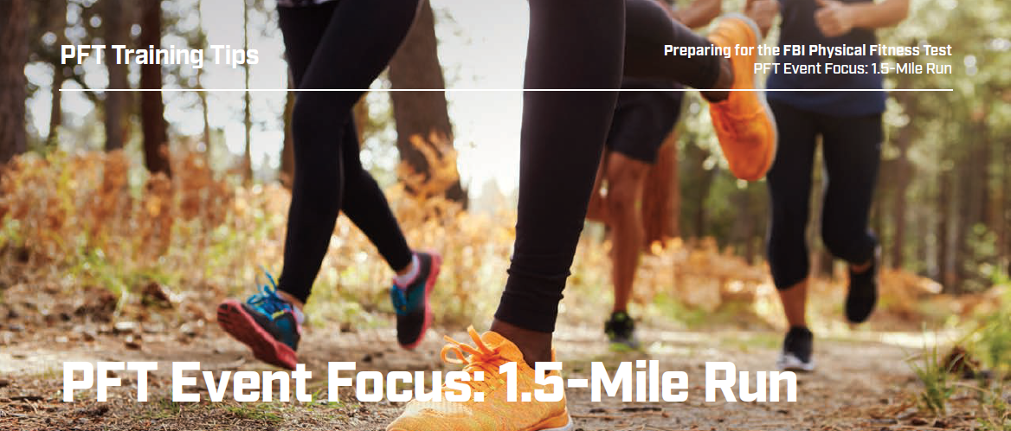

**Objective:** Provide a training template to prepare you for the 1.5-mile run. This run utilizes a combination of aerobic and anaerobic pathways. Contrary to popular belief, one does not get more anaerobic contribution of energy during this event. Successful completion relies more on the aerobic contribution. For example, an 800-meter event will be 60 percent aerobic and 40 percent anaerobic. A 1,500-meter event is 77 percent aerobic and 23 percent anaerobic. The cumulative effect of all other events puts a tremendous value on developing a better aerobic base. Our goal is to combine these pathways in any training modality.

**1.5-Mile Run Skill Builder:**

**Movement Preparation:** Improvement in running mechanics comes from consistent lower-body strength work. Multiply your body weight by two to three. That math is applied to the ground in every step. There can be over 1,500-foot strikes in the 1.5-mile run for most FBI Special Agents. The most important pillar in our curriculum is that you must have the strength to endure. The 300-meter Skill Builder will absolutely carry over to the 1.5-mile run. Your focus should be on the quality of those foot strikes, not the quantity. Heel strikes result in a higher braking force, reduced energy storage and a prolonged ground contact. Hit the ground with the forefoot or midfoot to minimize that shock. The mechanical advantage will enhance joint integrity and allow better economy of movement.

Complete recoveries between repetitions will build better capacities. As your fitness improves, incomplete recoveries between efforts will simulate the demands of the overall test. The anaerobic and aerobic systems should work synergistically. A consistent approach is mandatory to provide proper adaptation but be mindful of orthopedic concerns. The following drills may be simulated on most cardiovascular pieces (bike, rower). However, specificity with gravity and the ground must happen eventually.

**Warmup:** Utilizing approximately a 10-yard distance, perform a dynamic warmup emphasizing the running muscles. Begin with dynamic stretching while walking along the 10-yard distance, progressing to more dynamic movement drills such as lateral shuffles, carioca and tall-fall-run. Lunging, skipping, hopping and lateral shuffles will prepare the nervous system for linear work.

*Note: The following 1.5-mile Run Skill Builder Drills are not designed to be completed as a single workout. Ideally, you should manage a minimum of one drill a week for three to four weeks before progressing. Drills 1 through 3 are for the beginner, while Drills 4 through 6 are progressively harder. Some candidates may not be able to perform the specified sets or reps and more time may be needed between drills. Preparation will always determine function.*

Drill No. 1: Leg Cranks:

**Instructions:** You will perform 10 squats, 10 forward lunges, five split squats and five opposite leg split squats in a fast, controlled manner. Squats should be performed with the feet wider than shoulder-width apart. The movement is initiated by a hip hinge. At the bottom, the back and shin angle should be similar. In the forward lunge, the back should remain upright (back should look the same as when standing) in the bottom position of the lunge. You should strive for lunging to a depth in which the trailing knee is hovering just above the ground. For the split squat, you will take a shoulder-width stance and stagger your feet by several inches front to back. Then you will lower into the squat by hip-hinging and then return to the start position. The heel of the trailing foot should rise off the ground.



Drill No. 2: 3 x 20:

**Instructions:** This modality works well on a bike or rower. You will begin with a two-minute warmup, followed by three 20-second sets of a maximum effort. Recovery period is two minutes between each set. Finish the drill with a three-minute cool down.

Drill No. 3: Strides:

**Instructions:** You will run 100 meters and walk 100 meters (if you have access to a track, run the straightaways and walk the curves); performing six to eight repetitions. The cue is to float and be relaxed. Your efforts should be fast yet controlled. Recruiting fast-twitch muscle fibers and leg turnover is the objective. This is not a sprint drill.

Drill No. 4: 30/20/10:

**Instructions:** This modality works well on the track, treadmill or any cardiovascular piece. You will perform 30 seconds of easy-effort walking, 20 seconds of moderate-effort running and then 10 seconds of running at a markedly increased effort, every minute for five consecutive minutes (one set). Recover from two to four minutes, then repeat. Perform two to three sets. (Gear changes should be fast yet controlled).

Drill No. 5: 50/40:

**Instructions:** You will perform a 200-meter run (first repetition) followed by a 200-meter fast-walk recovery period. Immediately after the recovery walk, you will perform another 200-meter run (second repetition) in 10 seconds less time than the first 200-meter run, again followed by a 200-meter fast-walk recovery period. This completes one set. Perform two to four sets. (Example: The first repetition is clocked at 50 seconds; the second repetition after the recovery walk is clocked at 40 seconds. You are alternating between a moderate and fast effort. The goal is to maintain no more than 10 seconds difference between the first and second repetitions.)

*Note: You should adjust repetitions based on your level of fitness (a 40/30 application is acceptable). Additionally, as your performance with the drill improves, repetition times should be decreased (48/38 seconds, 46/36 seconds, etc.).*

Drill No. 6: Partner 400s:

**Instructions:** With a partner, you will run 400 meters while your partner rests. Upon completion, your partner will run 400 meters while you rest. This completes one set. Six sets complete the drill. You and your partner’s goals are to run the remaining five repetitions in a time no less than the time of the first repetition. If you do not have a partner, the rest period should be equal to the time it took to complete the first repetition.

**Drills to Solidify Good Running Mechanics:**

Running fast requires optimal form to maximize performance and minimize injury. The following drills will focus on developing the proper hip drive and arm action necessary to run fast.

Hopping Drill:

Hopping is a basic, minimal impact, plyometric exercise. Fast, repeated, multidirectional hops will foster lower-body joint integrity, enhance ankle stability and strengthen tendons. Hops are necessary for sedentary, older individuals to perform. Research shows tendons and ligaments degrade over time and ultimately become more susceptible to injury if one hasn’t been training explosively on a regular basis. Hops have been shown to warm up the central nervous system and prepare the body for explosive training.

1, 2, 3 Ankle Hops:

Stand on a solid surface such as the track, gym floor or pavement. This hop is performed by jumping and plantar flexing the ankles, then driving the balls of the feet into the ground. Repeat for three consecutive, stationary hops. Focus on slapping the ball of the foot against the ground and quickly pulling the toes toward the shin. With each hop, focus on building force and jumping higher. Tell yourself “the floor is hot” to minimize ground contact time. The knees should not be bending as in performing a squat and the heels shouldn’t be contacting the ground.

Line Ankle Hops (Forward ):

Find a line on the ground to hop over. Toes should be behind the line and feet should be shoulder-width apart. On the “go” command, you will hop back and forth (only clearing the toes over the line) as quickly as possible for the specified period. Again, remember that “the floor is hot” and you need to minimize contact time with the ground.

Line Ankle Hops (Lateral):

This is like the last drill except you will straddle the line with one foot next to the line. The feet should be parallel to the line and shoulder-width apart. On the “go” command, you will quickly hop back and forth, bringing the foot down on the other side of the line. There is a tendency to bring your feet together during this drill; keep your feet shoulder-width apart throughout the duration of the drill.

Start Drill:

Valuable time is lost with a poor start. The start should emphasize optimal positioning to efficiently impart force into the ground. This means the arms should be ready to aggressively punch forward and rip backward to maximize upper-body involvement. The body should be low to the ground with a slight forward lean in order to maximize force into the ground (with feet staggered, squat down with a forward weight shift, knees forward of the toes). The first several steps should be short and choppy in order to maximize steps into the ground for acceleration before gradually progressing to your normal stride length.

15-Meter Start Drill:

Set up on a starting line. Be mindful of the proper start position — staggered stance with the dominant leg forward, squat position with a forward lean onto the toes, lead leg with shin forward of toes, opposite arm forward of lead leg. On the “go” command, you will drive off both feet and quickly drive the backward arm forward. You will be taking many quick, short steps to accelerate.

Gradually, your stride should lengthen as maximal speed is achieved. Your normal stride length should not be a heel strike. If you are still unable to stop striking the heel, the distance should be shortened to a length that reinforces driving off the balls of the feet. To minimize heel striking, place the foot down at or behind the hip, instead of reaching the foot out in front. Recall the hip drive drill and perform more reps of this drill.

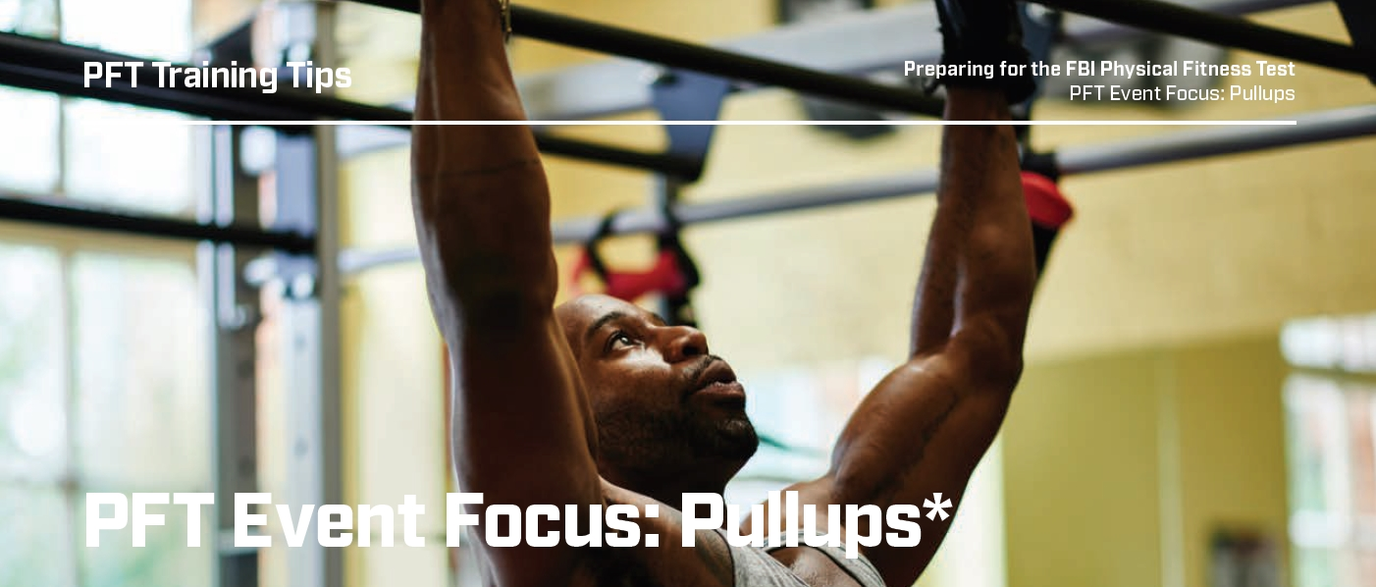

**Objective:** Provide an overview of the exercises and training techniques that will enhance the muscular strength and endurance necessary to maximize pullup performance.

*\*Note: Only candidates for the Tactical Recruitment Program (TRP) will complete this event.*

**Pullup Skill Builder:**

**Warmup:** Perform a 5- to 10-minute upper body dynamic warmup, including various crawls such as bear crawls, crab walks, etc.

Recommended Exercises for People Who *Cannot* Perform Pullups:

**Band-assisted Pullups:** Place a band around a bar and hook it around your knee or foot. The band will assist you on the upward phase of the pullup. Perform pullups as normal. The wider/shorter the band, the more assistance it will provide.

**Negative Pullups:** Start at the top of the pullup, then slowly lower to the bottom position for a count of 10. Either have a spotter push you back up to the top position or step on a bench or box to return to the starting position. Perform repetitions until you can’t lower for a count of 10.

**Bent-arm Hang:** Hold your position at a 90-degree angle at the elbow joint for a specified amount of time. Hold for 20 – 40 seconds and rest the same amount of time between sets.



**Hammer Curls:** Hold dumbbells so that your arms are at the sides with palms facing each other. Perform a biceps curl, keeping your hands facing each other. Perform 8 – 12 repetitions.

Recommended Exercises for People Who Can Perform Pullups

**Ratchet Pullups:** Perform one pullup for one minute (or other specific time). Start at the bottom position. Every five seconds raise up a little and hold the position for five seconds. At 30 sec­onds, you should be at the top of the pullup. Now lower yourself every five seconds holding the position until you are at the bot­tom of the pullup. Rest for one minute and perform again. If one minute is too hard, try 40 seconds (20 seconds up, 20 seconds down). If it is too easy, just add more time. Perform sets until the point of fatigue.



**Weighted Pullups:** Using a weight belt, weighted vest or dumbbell, perform repetitions of pullups, pausing at the top position for a count of one. Perform four to six repetitions.

**Isometric Holds:** Determine your “sticking” position (the point at which you usually get stuck when performing the pullup). Hold that position for a specified amount of time (20 seconds, one minute, etc.). Rest for one minute and repeat several times.

**Hammer Curls:** Hold dumbbells so that your arms are at the sides with palms facing each other. Perform a biceps curl, keeping your hands facing each other. Perform 8 – 12 repetitions.

**Programming:**

First determine if you can perform a pullup and then follow the recommended exercises to build strength and endurance. Everyone will respond differently to training. Experiment with the exercises and determine which ones work best for you.

Start off with low volume (sets times repetitions times weight) and gradually progress to higher volumes over the weeks and months that follow.

Pullups should not be performed every day. The recommendation is to practice pullups two or three times a week, with a day of rest in between.